
KNZ_GeoTrackLab ver 1.5.5.0 2024/11/05
Help documentation
- Operation introduction……………………………………………………………………………………………..2
a.) Introduction…………………………………………………………………………………………………....2
b.) Read RINEX file………………………………………………………………………………………………...4
c.) Read as sat solution…………………………………………………………………………………………4
d.) Read as pos solution………….………………………………………………………………………………6
e.) File format (.ksln)…………...…………………………………………………………………………………7
f.) File format (.ssln)……………...………………………………………………………………………………8
- Plot introduction…………………………………………………………………………………………………….8
a.) ENU (WSD) Plot………………………………………………………………………………………………..8
b.) Valid satellite number…………………………………………………………………………………………9
c.) Satellite orbit track (Dynamic)………………………………………………………………………………9
- Q&A…………………...……………………………………………………………………………………………10
- Quote……………….……………………………………………………………………………………………11
- Update notes……….……………………………………………………………………………………………11

Project site address: https://github.com/KenanZhu111/KNZ_GeoTrackLab

A. Operation introduction
a.) Introduction:
a) Project development history:
Date | Version | Program Name | Update
2024.09.21 | 1.0.0 | None (Console program) | New release
2024.09.28 | 1.0.8 | SPP_Calculate (GUI) | First release SPP_Calculate.
2024.10.05 | 1.1.0 | SPP_Caluclate & SPP_Plot (GUI) | First release SPP_Plot
2024.10.06 | 1.1.2 | SPP_Caluclate & SPP_Plot (GUI) | See update notes
2024.10.08 | 1.1.9 | KNZ_Caluclate & KNZ_Plot (GUI) | See update notes
2024.10.14 | 1.3.1 | KNZ_Caluclate & KNZ_Plot (GUI) | See update notes
2024.10.26 | 1.5.1 | KNZ_GeoTrackLab (GUI) | See update notes
2024.11.05 | 1.5.5.0 | KNZ_GeoTrackLab (GUI) | See update notes
The project has undergone two renames, as well as major software updates. The first time is rename form SPP_Calculate to KNZ_Satnav. The second time is rename as KNZ_GeoTrackLab, this update represents an important step forward for the project, entering a new phase.
From the very beginning of the console program, to now the full GUI interface, and the latest update of the 3D drawing module, cannot be separated from the support and encouragement of friends and relatives, but also accompanied by the guidance of good teachers, but also to learn and absorb the wisdom of many developers on the Internet, I would like to express my thanks here.
The development of this software is based on or using the products or open source software of the following companies, which are listed here to express my gratitude:
Microsoft: Visual Studio Community 2022, Visual Studio Code
JetBrains: PyCharm Community Edition 2024.2.1
MathWorks: MATLAB R2021b
RTKlib: RTKlib ver2.4.3 b34 ( https://www.rtklib.com/ )

b) Program main function introduction:
KNZ_GeoTrackLab(later replaced by "this program"), mainly supports the following functions:
Support version of RINEX:
RINEX of Observation of version 2.xx.(Support by KNZ_Convert)
RINEX of Observation & Navigation of version 3.xx.
RINEX of Observation of version 4.xx.
Support system of GNSS:
GPS: Satellite position solving & Receiver station orientation.
Galileo : Satellite position solving & Receiver station orientation.
GLONASS : Satellite position solving.
BeiDou / Compass : Satellite position solving.
Support method of orientation:
Pseudorange positioning.

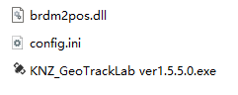
c) Program interface introduction:
The program is mainly composed of two parts, one is the executable file of the program, the second part is the function dynamic link library used to calculate the satellite position:
A-a-c-1. Program Structure(ver 1.5.5.0)
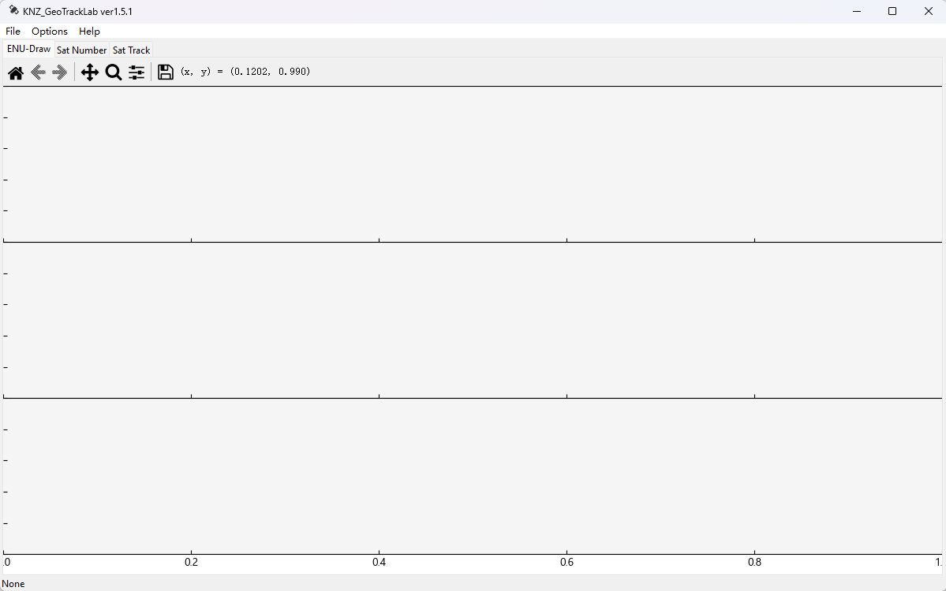
The following figure is the main interface of the program, which consists of the tool menu, drawing tab, drawing area and bottom status bar, The top toolbar consists of three parts, including file operations, setting options, and about information. The drawing tab mainly contains three types of image displays: ENU image of positioning accuracy, number of available satellites for positioning, and 3D satellite trajectory map.
A-a-c-2. Main program interface
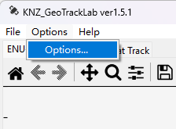
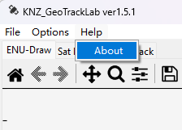
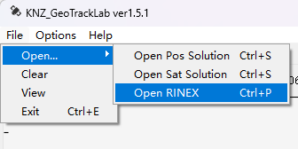
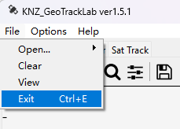
Click the top menu option to display the following interfaces:
A-a-c-6. Help card
A-a-c-4. File >Open… card
A-a-c-3. File card
A-a-c-5. Options card
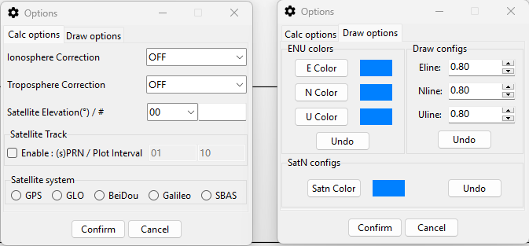
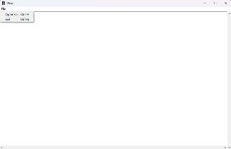
After clicking on the options such as Figure A-a-c-3(“View”). 4(“Open RINEX”). 5 . 6, the following windows will pop up respectively:
A-a-c-8. Options window(The two tabs are displayed on the left and right)
A-a-c-7. View window
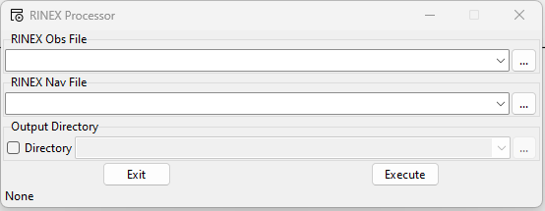
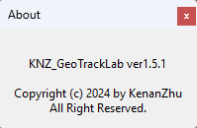
For specific interface operation logic, please see the following text.
A-a-c-10. About window
A-a-c-9. RINEX Processor window

b.) Read RINEX file:
a) Input the Obs & Nav file & Output sat solution file:
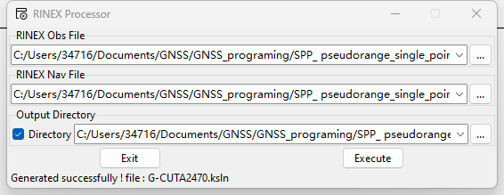
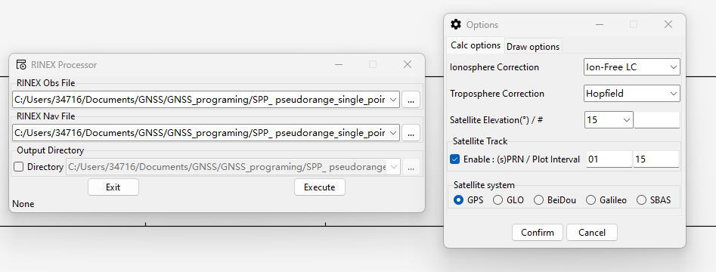
The current software only supports reading RINEX 3.xx version observations and broadcast ephemeris files. For specific support information, see A-b. First, open the File menu option, click the Open... secondary menu, select Open RINEX, and select the RINEX file input path in the pop-up interface. If the save path for the sat solution (.sp) is not selected, it will be generated in the same directory as the observation file. Click Execute, wait for the status bar to generate information like “Complete generate file : *.sp”, and generate the sat solution (.sp). It should be noted that the specific generated GNSS needs to be selected by clicking the Options menu option (SBAS is not supported yet).
A-b-a-2. RINEX Process ok
A-b-a-1. RINEX Process into sat solution
After processing, a sat solution (.sp) will be generated in the specified folder or in the same directory as the observations. For detailed information about the Sat solution (.sp) file, see section e.) of this chapter.

c.) Read as sat solution:
a.) Read options:
First of all, you need to understand that the naming of the generated sat solution (.sp) file is related to the satellite system. A sat solution file only stores the solution of one satellite system, so mismatched system selection will cause data reading error. The operation is the same as when generating the solution. Open the Options window, select the ionospheric and tropospheric correction mode in Calc options, and select the matching satellite system. Switch to Draw options to adjust the image quality, such as the color and quality of the image.
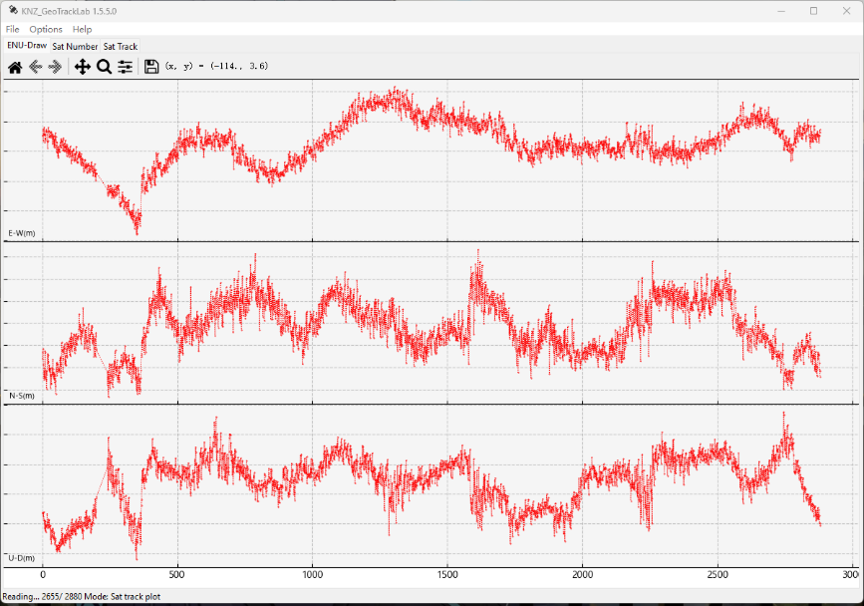
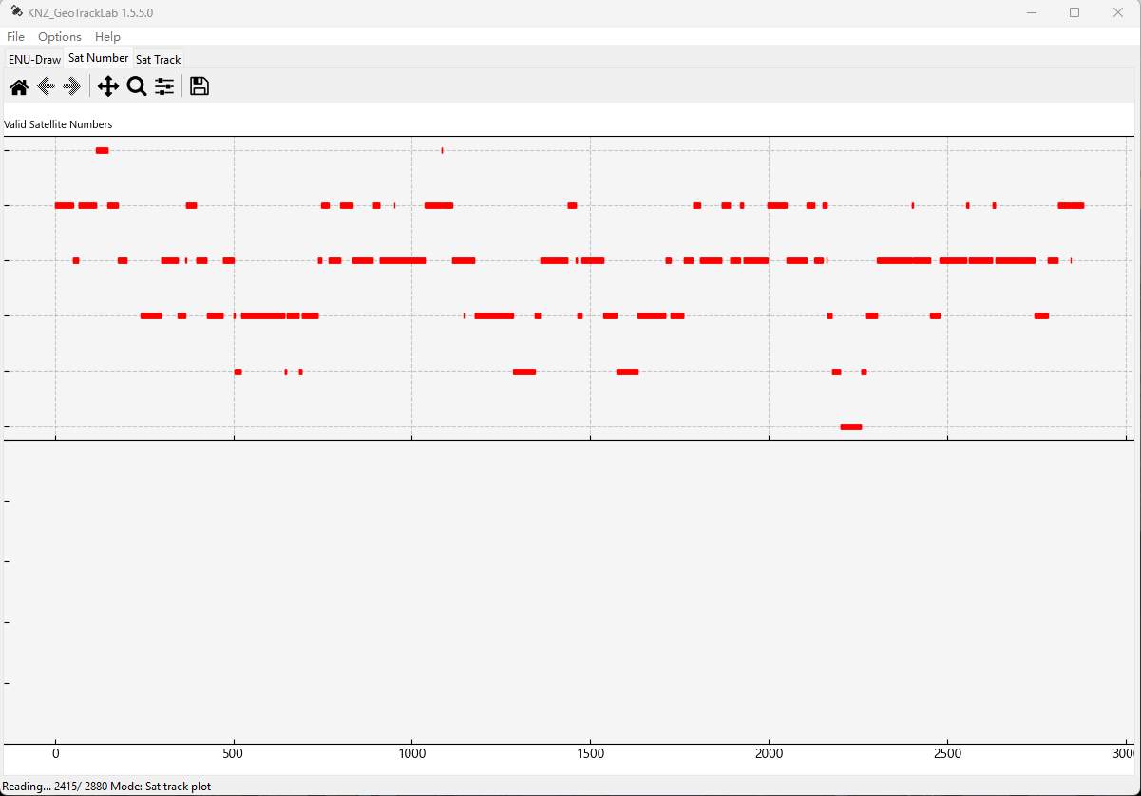
After completing the tab settings, you can open the sat solution (.ksln) for positioning and analysis:
A-c-a-1. Position solution figure of ENU(WSD)
Thanks to the powerful functions of the matplotlib open source module, you can use the toolbar above the image area to scale, move, save, and other operations on the image.

d.) Read as pos solution:
a.) Read options:
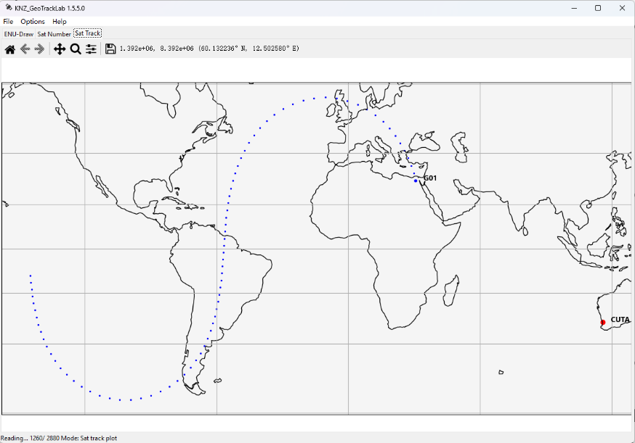
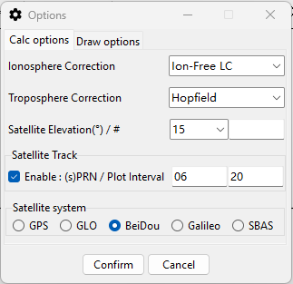
The new version deletes the 3D mapping that is too demanding on performance and difficult to optimize in development, replaces it with Mercator projection, and implements the animation demonstration of satellite selection and sampling interval, which must first check the enable trajectory mapping function in the Settings window. Again, you need to match the satellite system to the file or it won't work. Select the model you want to draw and the sampling interval (determines drawing speed and track fluency)
A-d-a-1. Ooptions for dynamic figure
A-d-a-2. Dynamic figure of satellite trajectory

e.) File format (.ksln):
a.) Name of file (.ksln) :
The sat position file name consists of two parts. The capital letter at the beginning indicates the satellite system to which the solution belongs:
G > GPS
E > Galileo
C > BeiDou / Compass
R > GLONASS
S > SBAS
The second part is the RINEX original observation file name, ending with the .ksln extension.

b.) Header data of file (.ksln) :
The header file data mainly indicates the necessary information of the file generation date and the original observation value. The following is a detailed introduction:
Header Label | Description | Format
GENERATE PROGRAM | Program that generate this file. | 24S 1X -40C
GENERATE TYPE | The data type of this file. | 24S 1X -20C
GENERATE TIME | The time of this file was generated:  DayofWeek Mon. DayofMonth Time Year | 24S 1X 3C 1X 3C 1X HH-MM-SS 1X 4D
OBS FILE PATH | File path of RINEX observation file. | 24S 1X -260C
NAV FILE PATH | File path of RINEX navigation file. | 24S 1X -260C
TIME OF FIRST OBS | Time of first observation record :  Year Month Day Hour Min Sec | 24S 1X 4D 4X 2D 1X 7.4F
TIME OF LAST OBS | Time of last observation record :  Year Month Day Hour Min Sec | 24S 1X 4D 4X 2D 1X 7.4F
APPROX POSITION XYX | The approximate position in ECEF of receiver station in observation file. | 24S 3X 13.4F
APPROX POSITION BLH | The approximate position in BLH of receiver station. | 24S 3X 13.4F
INTERVAL | The observe interval of each epoch. | 24S 1X 5.2F
END OF HEADER | The end sign of header file. | 1S

c.) Body data of file (.ksln) :
The new data file contains only the longitude and latitude information of the satellite involved in the position solution and the relative error obtained from the solution, which is the WGS-84 ellipsoidal coordinate system.
Data Format | Description
>5D lat/r lon/r alt/m | 5D > Epoch number
X2D 3X 9,05F 9,05F 15,05F  Rec:3X 9,4F 9,4F 9,4F  Rec:insufficient quantity of sat, sat=2D. | X > Satellite system:  G > GPS  E > Galileo  C > BeiDou  R > GLONASS  S > SBAS  2D > sPRN 3X > Lat. Lon. Alt.  Rec: 3X > dX. dY. dZ.
Example
>00001 lat/r lon/r alt/m
G19 0.353354 2.428820 19945427.32510
G ……
Rec: 1.0247 -8.0152 0.0552

f.) File format (.ssln):
a.) Name of file (.ssln)
The sat position file name consists of two parts. The capital letter at the beginning indicates the satellite system to which the solution belongs:
G > GPS
E > Galileo
C > BeiDou / Compass
R > GLONASS
S > SBAS
The second part is the RINEX original observation file name, ending with the .ssln extension.

b.) Header data of file (.ssln)
The new data file header remains the same as ksln, as detailed above
c,) Body data of file (.ssln)
Data Format | Description
X2D 3X 9,05F 9,05F 15,05F>>5D | X > Satellite system:  G > GPS  E > Galileo  C > BeiDou  R > GLONASS  S > SBAS  2D > sPRN 3X > Lat. Lon. Alt.  5D > Epoch number
Example
G01 -0.164261 -2.532305 20419585.33787>>00001

B. Plot introduction:
a.) ENU (WSD) Plot:
B-a-1. Figure of ENU(WSD)
This figure shows the deviation between the receiver position calculated after satellite pseudo-range positioning and the actual position. It is specifically shown in three directions: E (east), N (north), and U (up). After reading the sat solution, the GDOP value of the positioning will be displayed on the image in the E direction (gray thin line). Missing epoch information will be calculated by default as 0

b.) Valid satellite number:
B-b-1. Figure of valid satellite numbers
This figure shows the number of satellites available for position solution in the solved epoch number, and the trend of the number of satellites is shown in the scatter plot.

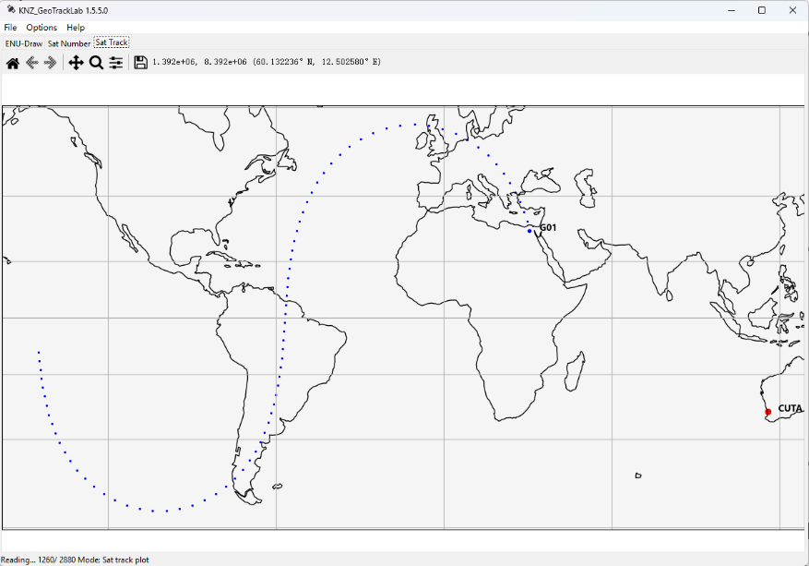
c.) Satellite orbit track (Dynamic):
B-c-1. Figure of satellite trajectory
This graph is only generated after reading the ssln solution. Based on this graph, the satellite trajectory at the subsatellite point of the station can be analyzed, thereby analyzing the satellite trajectory and satellite visibility, and analyzing the impact of satellite distribution on the station solution.

C. Q&A:
Q: Is the software and source code before this version still available?
A: No, because some fundamental calculation logic has changed after the module merger, and the output file format is not compatible, so it has been abandoned. The source code can be obtained in the code modification history.

Q: When will the pseudo-range single point positioning of GLONASS and BeiDou be realized?
A: Not sure yet, this is a systematic work and it will take more time to deal with the details.

Q: 3D drawing is running very slowly, can this be fixed?
A: This is a problem with the matplotlib module, which requires hardware support. I am not clear about the principles of graphics card hardware calls, so I will not consider changing it for the time being. However, I can improve fluency by changing the data sampling rate.

Q: What is the purpose of the blank area below the satellite count plot?
A: That is a drawing area reserved in advance for subsequent development. Later, we will consider developing data visualization analysis of RINEX observation files, such as the number of visible satellite bands. Combined with the broadcast ephemeris, we can draw images of satellite health status, etc. The specific details will be based on the development progress.

Q: Does the program support RINEX observation files and broadcast ephemeris files of version 2.xx?
A: The software itself does not support it. The software was originally developed based on RINEX 3.xx observations and broadcast ephemeris files. However, you can use another tool software developed by me to convert the 2.xx version of RINEX observation files to perform the corresponding pseudorange positioning. However, the software does not natively support the reading of RINEX 2.xx version of broadcast ephemeris. As for other types of files other than RINEX 3.xx observations and broadcast ephemeris files, the software does not support them. There is no relevant development plan for the time being.

Q: Does the software support phase observation type, differential positioning, precise single-point positioning and other positioning methods?
A: No, due to limited knowledge accumulation and development experience, I am not yet able to carry out relevant development

D. Quote:
Websites:
| https://blog.csdn.net/why1472587?type=blog
| https://zhuanlan.zhihu.com/p/416072448
| https://www.pygmt.org/latest/index.html
| https://blog.csdn.net/FrankXCR/article/details/135438701
| https://www.csno-tarc.cn/system/constellation
| https://www.researchgate.net/figure/GLOANSS-ground-tracks-of-satellites_fig2_383590476
|
Papers:
| [1]葛奎,王解先. GLONASS卫星位置计算与程序实现[J]. 测绘与空间地理信息,2009,32(02):137-140.
| [2]龚明杰."GPS与GLONASS多频组合伪距单点定位精度分析." 测绘与空间地理信息 45.02(2022):115-117+122.
| [3]王强昆, 谢卫杰,and 王耀鑫."BDS-2/BDS-3伪距单点定位精度分析." 测绘与空间地理信息 44.10(2021):156-159.

Update notes:
Update: 2024/11/05: ver 1.5.5.0
- KNZ_GeoTrackLab: Fix some bug, Optimize UI logic
- KNZ_GeoTrackLab: New added function of save and change file for View
- KNZ_GeoTrackLab: Sat track projection plot changed as Mecator projection and relize the display by dynamic, sat prn selection, selection of sample rate/inteval of plot

Update: 2024/11/03: ver 1.5.4.6
- KNZ_GeoTrackLab: Fix some bug, Modify some UI logic
- KNZ_GeoTrackLab: Remove 3D plot function
- KNZ_GeoTrackLab: Merge some functions and concentrated
- KNZ_GeoTrackLab: New added: Sat track projection ui

Update: 2024/10/31: ver 1.5.3.4
- KNZ_GeoTrackLab: Fix some bug, Modify some UI logic.
- KNZ_GeoTrackLab: Optimize code structure.
- KNZ_GeoTrackLab: New added: Elevation angle option.

Update: 2024/10/28: ver 1.5.3.1
- KNZ_GeoTrackLab: Fix some bug.
- KNZ_GeoTrackLab: Optimize code structure.

Rename the Project & Update: 2024/10/26 ver 1.5.1
- First release KNZ_GeoTrackLab.
- KNZ_Calculate: Merged with KNZ_Plot.
- KNZ_Plot: Merged with KNZ_Calculate.
- KNZ_GeoTrackLab: Support GPS & BeiDou & Galileo & GLONASS.

Update: 2024/10/14 ver 1.3.1
- KNZ_Calculate: Support GPS & BDS & Galileo.
- KNZ_Plot: Support GPS & Galileo.

Update: 2024/10/09 ver 1.2.0
- KNZ_Calculate: Modify some crash.
- KNZ_Calculate: Optimize use experience.
- KNZ_Plot: Modify UI..

Rename the Project & Update: 2024/10/08 ver 1.1.9
- First release KNZ_Plot ,KNZ_Calculate.
- KNZ_Plot: Modify UI.
- KNZ_Calculate: Modify UI.

Update: 2024/10/06 ver 1.1.2
- SPP_Plot: Fix some bug.
- SPP_Plot: Optimize use experience.
- SPP_Calculate: Optimize code structure.
- SPP_Calculate: Modify UI.

Update: 2024/10/05 ver 1.1.0
- First release SPP_Plot
- SPP_Calculate: Modify UI.

Update: 2024/09/28 ver 1.0.8
- First release SPP_Calculate.
- Optimize code structure.

Update: 2024/09/26 ver 1.0.3
- Fix some bug.
- Optimize use experience.

Update: 2024/09/23 ver 1.0.2
- Fix some bug.
- Modify some crash.

Update: 2024/09/22 ver 1.0.1
- Fix some bug.
- Modify UI.

Update: 2024/09/21 ver 1.0.0
- Fix some bug.
- Optimize use experience.

Update: 2024/09/20 ver 0.9.1
- First release.

Copyright © 2024 by KenanZhu. All Right Reserved.

